**Big Mountain Resort – Facilities and Ticket Prices Report**

Isaac Paulson

**Business Problem**

The executives at Big Mountain ski resort suspect that the resort may not be maximizing returns relative to its position in the market. At the moment, pricing structure is based on market average, with a premium added for Big Mountain’s superior facilities. However, the executives also feel that the resort is not capitalizing on its facilities as much as it could. The business would like a better sense of how important some facilities are compared with others. The purpose of this data science project is to come up with a pricing model for ski resort tickets in our market segment that functions better than a simple market average, taking into account which facilities matter the most to visitors (actual and potential).

**Data Exploration**

The data in this project came from a CSV file provided by the resort’s database manager. The dataset contains categorical information of names, states, and regions for 330 ski resorts. It contains numerical information such as elevations and vertical drop, number and types of transport facilities, surface area and skiable terrain, number of and information on runs, snowfall and snow-making abilities, days open (weekdays and weekends), and, importantly, ticket prices. This figure shows the average ticket price by state, for adult weekday and weekend tickets. Visually, it shows Montana to be somewhere near the middle, but towards the lower half of ticket prices.

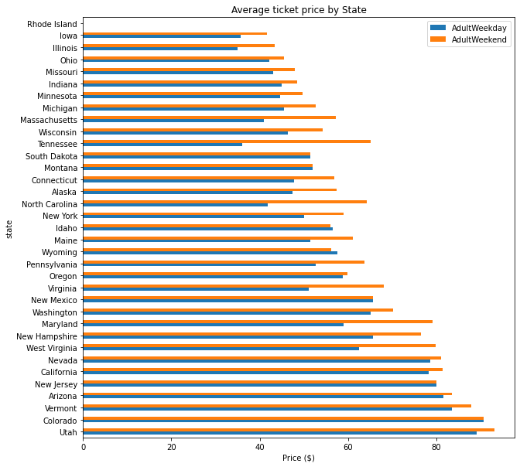

The next group of figures shows the correlations between ticket price and various features of the resort. As the figures show, the features most correlated with ticket prices are vertical drop, number of fast quads, runs, total number of chairs, and resorts per 100,000 people in a state.

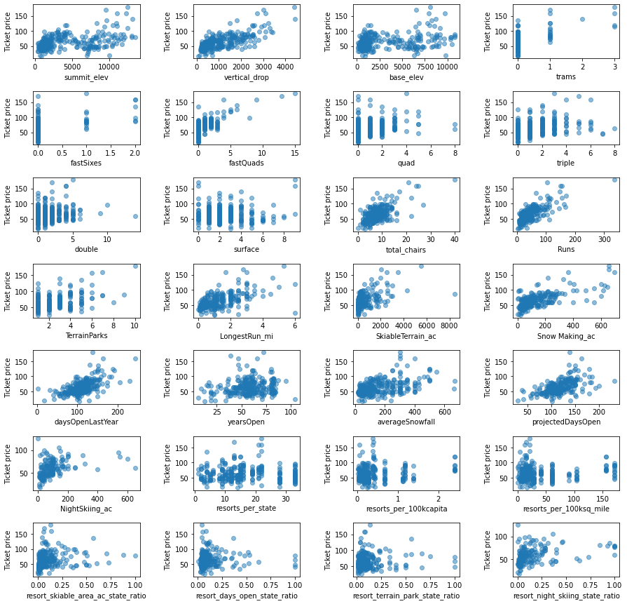

**Modeling and Conclusions**

Without considering any modelling, the average ticket price in Big Mountain’s market is $63.81. Big Mountain’s is currently more expensive at $81. There is, however, room to make adjustments and raise the ticket price for Big Mountain.

Modeling suggests that the most important features affecting ticket price are number of fast quads, number of runs, snow making and vertical drop.

Executives at Big Mountain have shortlisted the following options for making adjustments to facilities and ticket prices:

1. Permanently closing down up to 10 of the least used runs. This doesn't impact any other resort statistics.
2. Increase the vertical drop by adding a run to a point 150 feet lower down but requiring the installation of an additional chair lift to bring skiers back up, without additional snow making coverage
3. Same as number 2, but adding 2 acres of snow making cover
4. Increase the longest run by 0.2 mile to boast 3.5 miles length, requiring an additional snow making coverage of 4 acres

Modeling suggests that option 2, increase the vertical drop by adding a run to a point 150 feet lower down but requiring the installation of an additional chair lift to bring skiers back up, without additional snow making coverage, is the best option. This option requires installation of an additional chairlift, but not does not require any additional snow coverage – thus no additional snow-making would be required. Further, the model suggests that ticket price could be updated by about $9, providing additional income and support for a new lift.